LIMITED LIABILITY COMPANY LASERWAR

SPECIFICATION

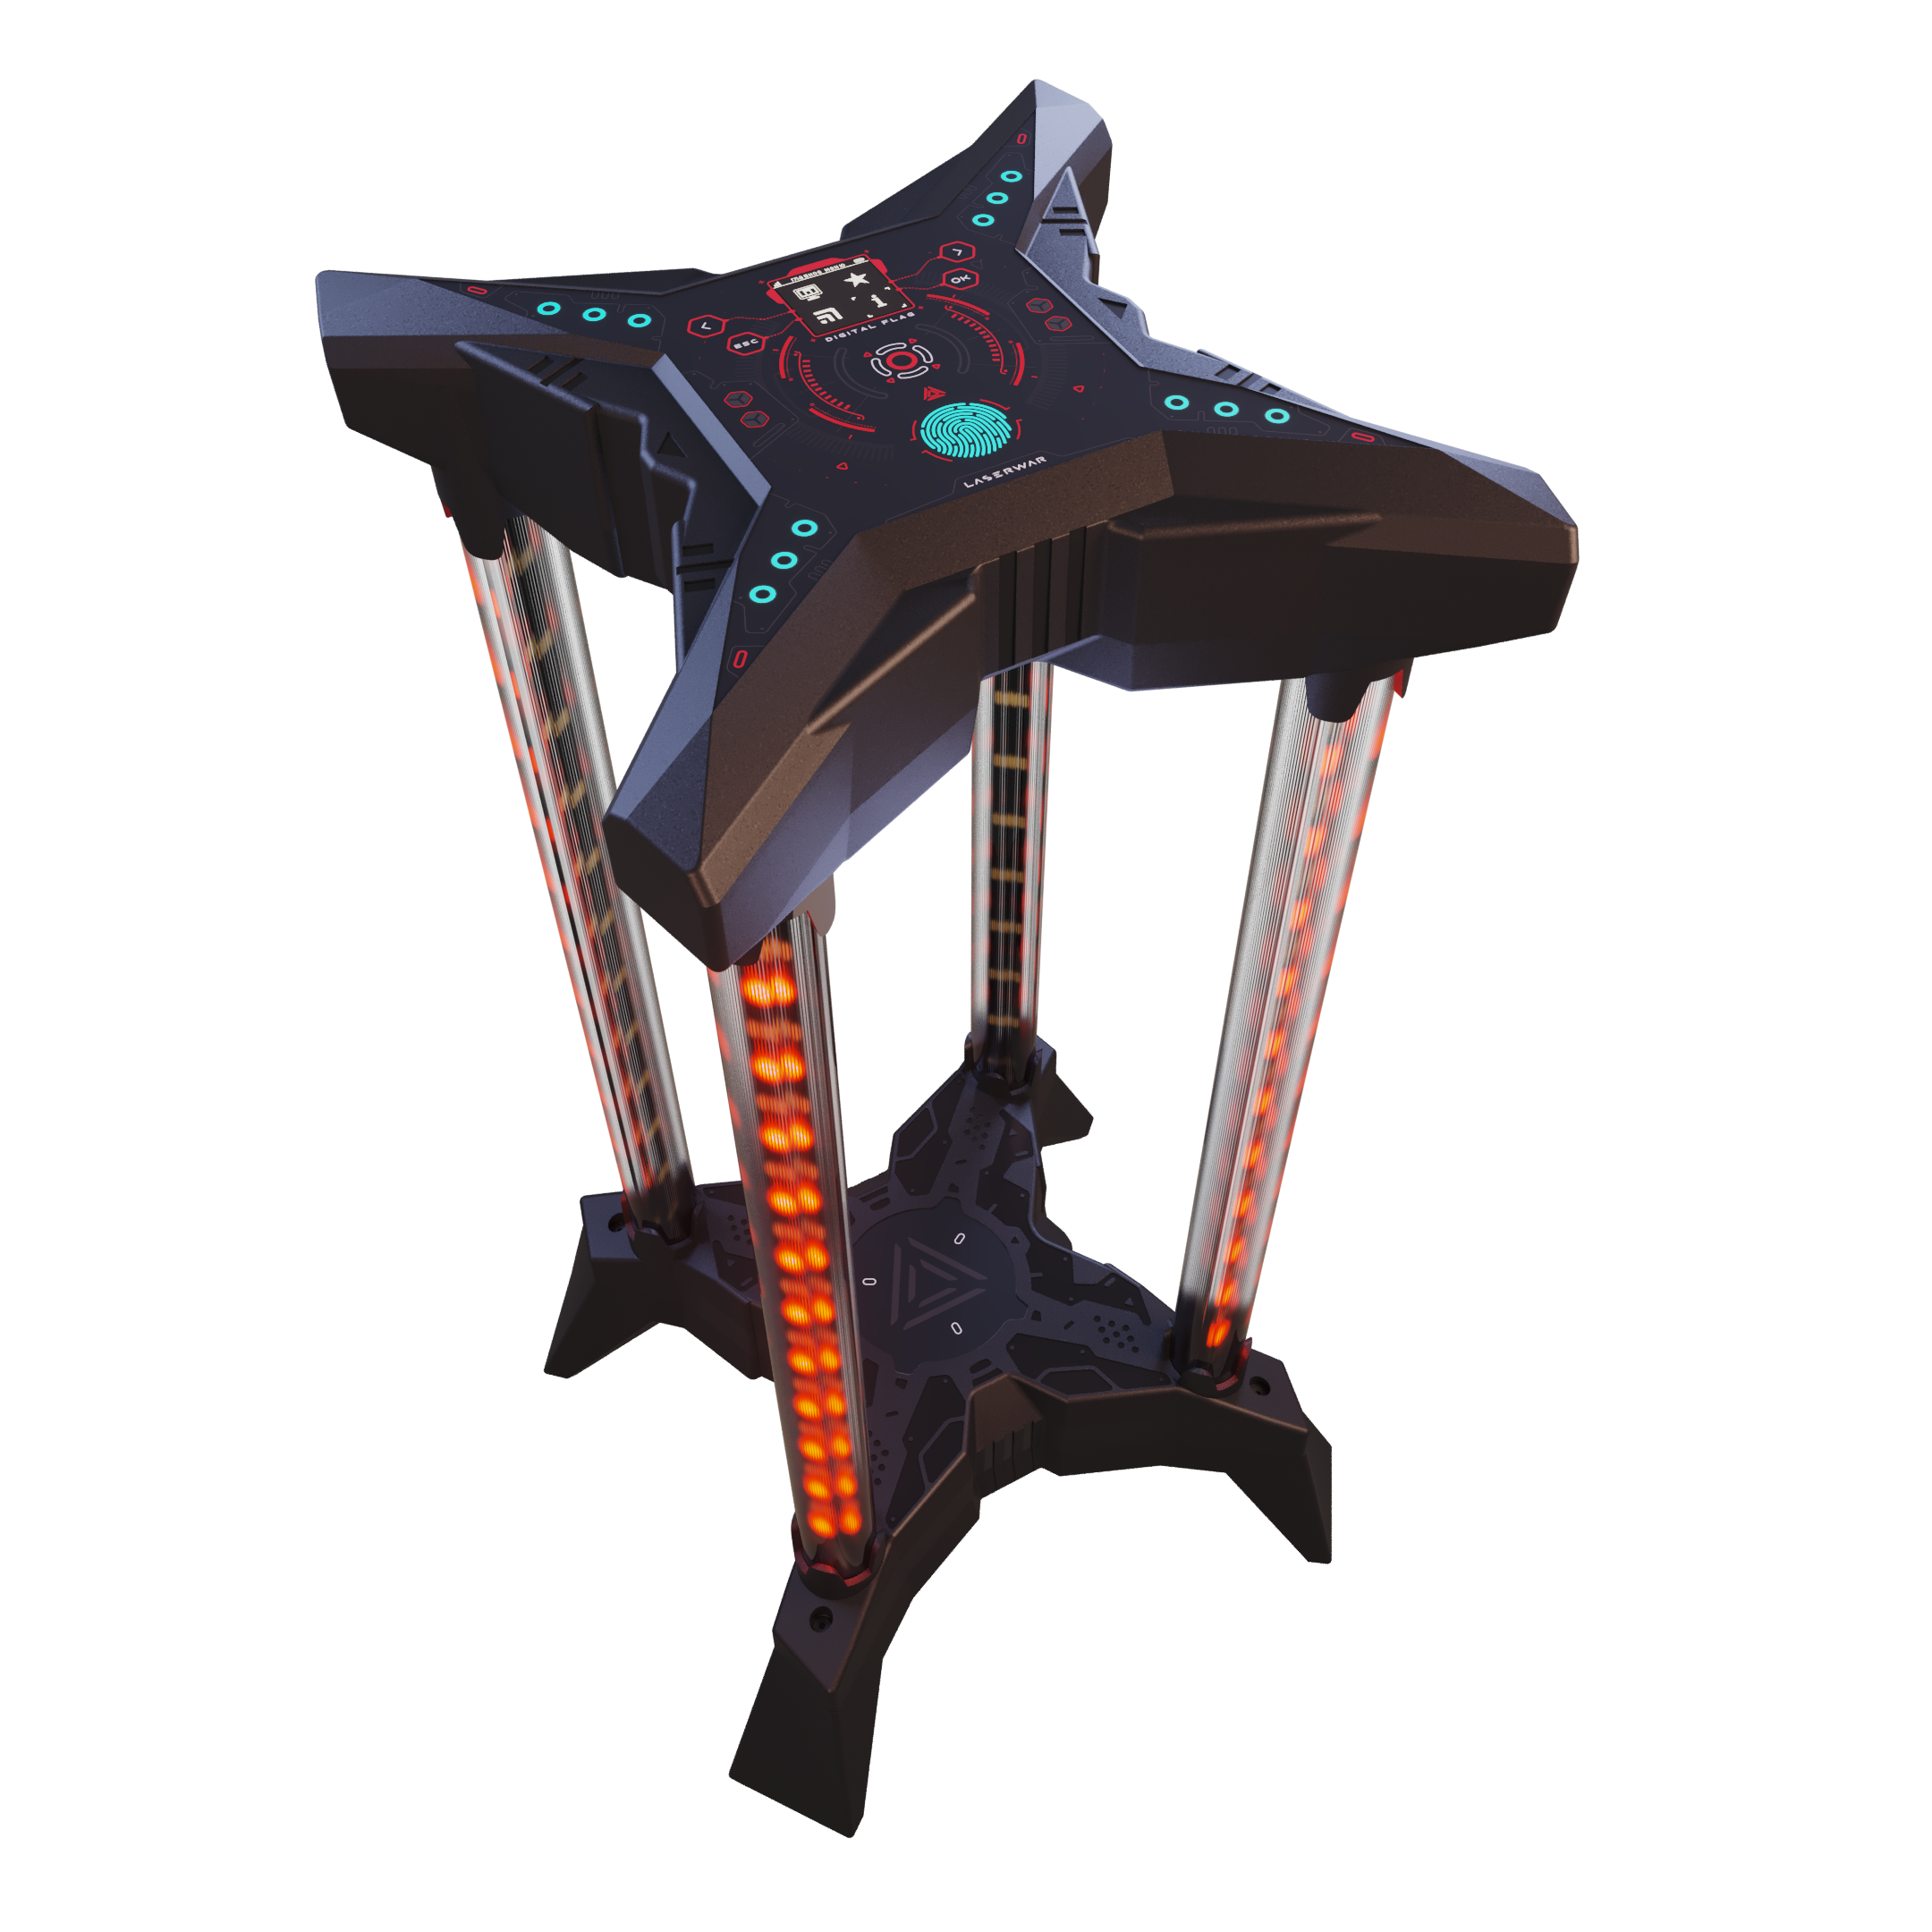

GAME SET
"Digital Flag"

1. Description
The Digital Flag is intended for use in various scenarios of laser tag games.

2. Scope of application
The Digital flag can be used in almost all scenarios of laser tag games (as a virtual flag, basic first aid kit, control point, radiation point, command base). A set of functions makes the Digital flag a universal device.
3. Package Contents
1. Digital Flag - 1 pc.
2. Product specification - 1 pc.

4. Basic technical data
Height, mm | 606
Width, mm | 330
Supply voltage, V | 7,4
Battery capacity, Ah | 8,8
Weight, kg | 2,7

5. Device
Digital flag is made in a shockproof plastic, a battery element is installed at the bottom, and control units at the top.

6. Maintenance
For the normal operation of the equipment, care must be taken for all the elements of the kit. Avoid contamination and damage to the IR diode. Do not allow moisture to enter the cabinet. Timely charge the battery. The recharging of the kit is carried out with the help of a charger for lithium batteries (not included in the scope of supply and is purchased separately). Avoid strikes.

7. Instructions for use
The Digital Flag is activated with a button on the top of the device. The buttons on the front panel are used to configure, select a scenario, start the game.
Seven scenarios are available: «Digital flag», «Control point», «Confrontation», «Military base», «Outpost», «Hospital», «Arsenal».
Scenario parameters are configured in the “Scenario” settings menu of the Digital Flag.
The settings can be reset to default.
2
3
8. Warranty
The manufacturer guarantees the reliability of the operation of the individual "LASERWAR" kit, provided that the user meets the operating conditions. Technical support is provided within 12 months from the date of sale. The manufacturer undertakes to replace or repair the individual set of equipment free of charge, provided that the consumer observes the rules of transportation, storage, operation and payment for the delivery of faulty equipment to the city of Smolensk.
On the batteries, speakers, IR modules, the warranty is 14 DAYS. These accessories are consumables.
ATTENTION! In the event of improper use of batteries (charging by an inappropriate type of charger), the battery warranty does not apply!

9. Contact information
Official site:
Www.laserwar.ru
Email:
Info@laserwar.ru
Support@laserwar.ru Date of purchase:_______________


______________________________________

Rules of operation of equipment
1. Weather conditions. In the production process, the equipment is tested for operation under various weather conditions. Despite this, we strongly do not recommend using the equipment in rain and temperatures below -20 ° C.
What you need to know when operating gaming kits in adverse weather conditions?
Most importantly, avoid getting moisture inside the device. If this happens - stop operation, dry the equipment at room temperature for at least 2 hours.

2. Power source. As a power source in the game kit Digital flag used lithium batteries with a nominal voltage of 7.4 V.
Charge only under supervision, no more than 3 hours.
Store the equipment in a well-ventilated place at a temperature of +18 ° C to +30 ° C and relative humidity of 45 to 65%.
On the batteries, speakers, IR modules, the warranty is 14 DAYS. These accessories are consumables.

ATTENTION! In the event of improper use of batteries (charging by an inappropriate type of charger), the battery warranty does not apply!

5
4


Dear customer!
LLC "Lasertag" welcomes you and thanks you for choosing our products, and also expresses confidence that the product you purchased will bring you pleasure and will last a long time. This coupon establishes a warranty liability for the product in the amount provided by the Law of the Russian Federation "On Protection of Consumer Rights".
This warranty card is valid for 12 months from the date of purchase of the product subject to the terms of the guarantee.
Terms of guarantee:
1. The warranty becomes effective upon presenting this coupon, which indicates the serial number of the product and the date of purchase, confirmed by the service center.
2. These warranty obligations apply to products purchased only from the official representative of OOO "Lasertag", or its Official Dealer.
3. This warranty is void if defects in the product have occurred in the event of:
- non-observance of Instructions for use;
- mechanical damage;
- ingress of foreign objects, liquids, etc .;
- animal activities;
- unauthorized access to the units and parts of the product of persons not authorized to carry out the specified actions;
- use of the product for purposes for which it is not provided;
- acts of force majeure (natural disaster, fire, accident, etc.);
- failure of the product due to incorrect connection, a faulty electrical outlet and / or poor maintenance of the product.
4. If the warranty card is lost, a duplicate is not issued.

Information about the repairs carried out during the period of guaranteed service (to be filled in by the service center performing the warranty repair).

Date:__________________Completed work:  _____________________________________________________________________  Printing Service Center | Date:__________________  Completed work:  _____________________________________________________________________  Printing Service Center
Date:__________________Completed work:  _____________________________________________________________________  Printing Service Center | Date:__________________Completed work:  _____________________________________________________________________  Printing Service Center
Date:__________________Completed work:  _____________________________________________________________________  Printing Service Center | Date:__________________Completed work:  _____________________________________________________________________  Printing Service Center

6
7

